Introduction

The new south transept window was commissioned in 2003 to mark the fortieth anniversary of the Stour Music festival, and to celebrate the life of its founder, the eminent counter-tenor, Alfred Deller.

The window had been ‘temporarily’ blocked in 1957, pending the completion of more pressing restoration work to the rest of the building and the availability of the necessary funding.

The plan was to reproduce the design of the corresponding north transept window, thus restoring both the sense of space and light so important to this interior, and the richness of detail, which was an essential counterpoint to the simplicity of the C14th architecture. The reopening of the window was to have a dramatic effect, both in reviving a dead area of the church’s interior and restoring externally the aspect of its southern elevation.

The project to restore the window was undertaken in 2003 by Friends & Supporters of Stour Music, who contributed generously to raise the £100,000 required. Stonework restoration was carried out under the supervision of the church architect, Robert George, by the Cathedral Works Organisation, Chichester, and the new glass was designed and made by Léonie Seliger in the Cathedral Stained Glass Studios, Canterbury.

The window, together with the memorial plaque on the west wall of the transept, which was carved by Michael Rust of Hastingleigh, was dedicated by the Very Revd. Robert Willis, Dean of Canterbury, in a ceremony held on 29th May 2004.

Stour Music

Memorial Window

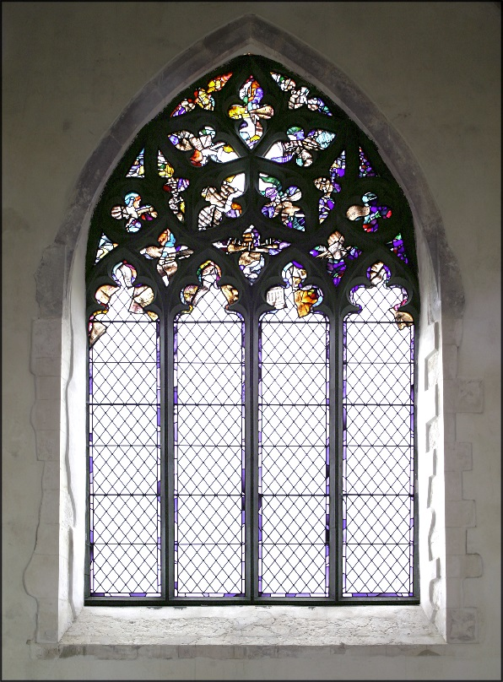

© Dean and Chapter of Canterbury

All Saints’ Church
Boughton Aluph
Kent

The Design of the Window
by Léonie Seliger

The brief for the stained glass was very short: the window had to celebrate music in some way, if possible relating to the revival of Early Music. The committee approached three different studios, amongst them the Cathedral Studios at Canterbury, all of whom offered designs. Here at Canterbury we are in the fortunate position of having several designers on the staff, all working in their own very distinctive styles. We therefore submitted four different designs, and to my great delight my design was chosen by the committee.

The Design
I am actually no stranger to All Saints’ Church or to Stour Music. Having discovered the festival about thirteen years ago, and being particularly fond of Early Music, I had since made a point of going to as many concerts as possible.

In thinking about the design, three things went through my mind: the first was how to link the coloured tracery with the clear lancets. I felt there could not be too sharp a break between the two areas; that some of the colour had to trickle down into the tops of the lancets, and some of the clear glass had to appear in the tracery. The second thought was: how to make the design relevant not only to its subject but also to the building it will live in? And finally: what does music look like? I will come back to this last question later. The window was to be the first major addition to All Saints’ Church in a very long time indeed. The challenge to the stained glass designer was to add a new dimension to the ancient building without adversely affecting the aesthetic balance of this historic place.
Continued overleaf……………

Fragments

All Saints’ Church is characterised by the fragmentary survival of its decoration, be it stained glass, wall paintings or even lime render. This fragmentary survival also appears in music before 1750. Only bits and pieces have come down to us, often by pure chance. Music was seen as transitory and disposable. In the absence of sound recording what we are left with is an incomplete paper-trail of sheet music. These considerations gave me a point to start from. Rather than depicting musical instruments – tempting as it may be, given all the weird and wonderful shapes of those early instruments – I would scatter fragments of sheet music over the window. A trawl through the internet produced facsimiles of manuscripts from a number of early composers.

Fig.1 Detail of the tracery showing a fragment of a motet by Vivaldi, Nulla in mundo

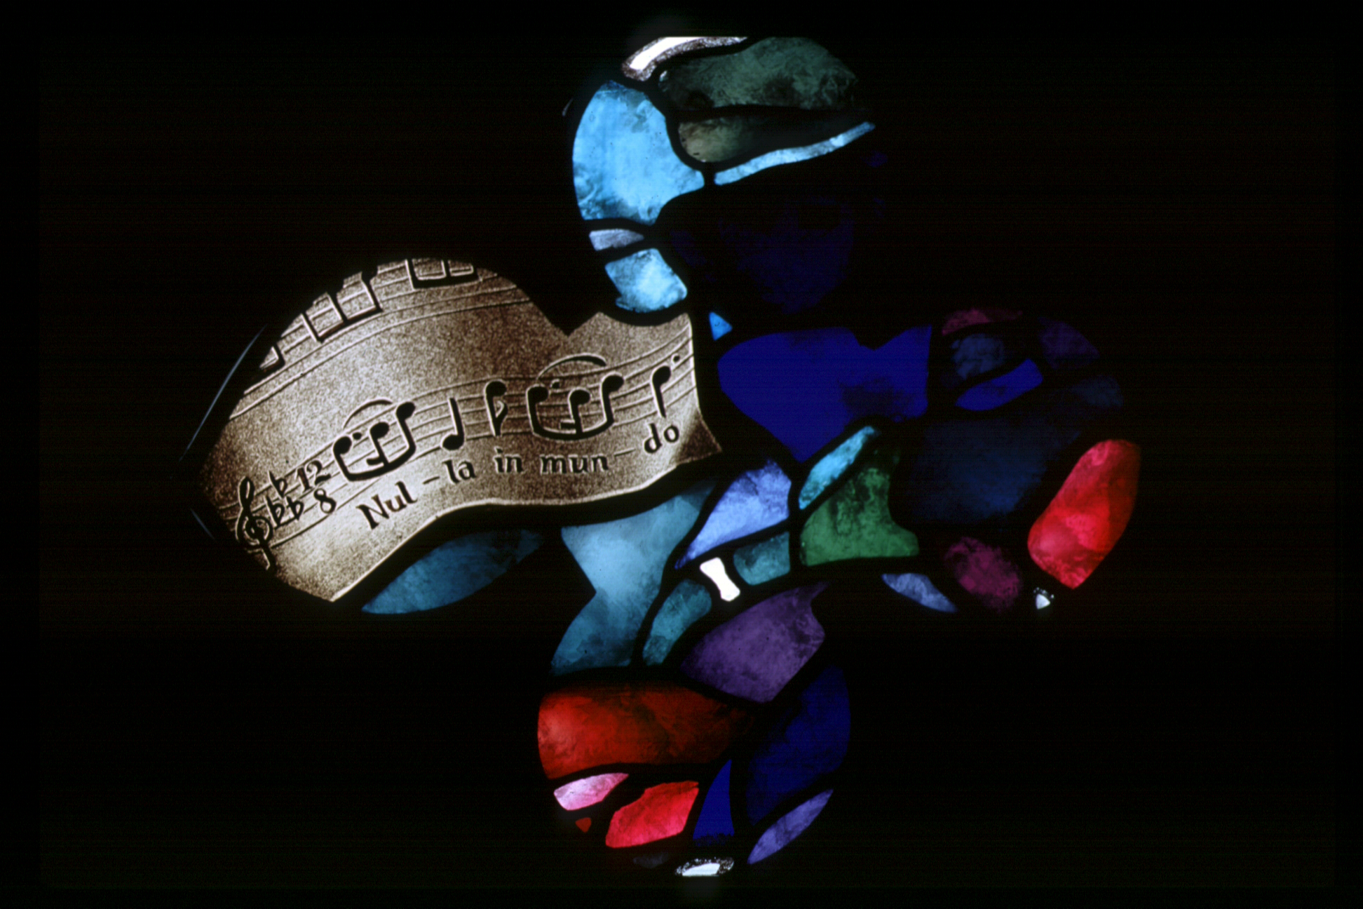
© Dean and Chapter of Canterbury

Cressida Annesley helped me greatly by finding some early manuscripts in the Cathedral’s archives,thus giving local colour and religious relevance to the music. In addition, Mark Deller, the festival director, provided me with a list of musical quotes

to be included, many of them favourite pieces of his father, Alfred.

Synaesthesia or what does music look like?

Many of us have, to some extent at least, the ability to link two or more senses together. This condition is called synaesthesia and its most common form is the association of certain sounds with certain colours. The experience is entirely personal, so that very few people with this ability will agree on what colour, say, a C sharp played on an oboe is. I am happy to say that I am only very slightly synaesthetic, since the condition in its extreme form can be rather overwhelming. In the window, the colours that envelop the sheets of parchment and paper therefore represent my personal experience of different musical moods, as well as the sounds of individual instruments. The rich deep purples, blues and greens may be reminiscent of organ tones, the bright yellows and reds of brass instruments. The colours also represent the different times of the day, with cool pale blues, greys and yellows in the eastern corner of the window, hot yellows, pinks and reds at the apex (south) and deep greens and blues in the western corner.

The Perpetual Canon and the Music of the Spheres

During my research into early manuscripts, I found a delightful 14th century “perpetual” canon
written on circular staves (see Fig.2). I decided
to use this as the unifying element for the whole tracery, with the staves gently rippling through the colours and fragments and the numes picked out in opaque white. The concentric circles are also reminiscent of the concept of the Music of the Spheres, the celestial harmony emitted by the universe, an idea very much in vogue in the Renaissance and Baroque periods.

Fig.2. Baude Cordier’s late C14th canon Tout par compass, revolves around the centre of the rose.
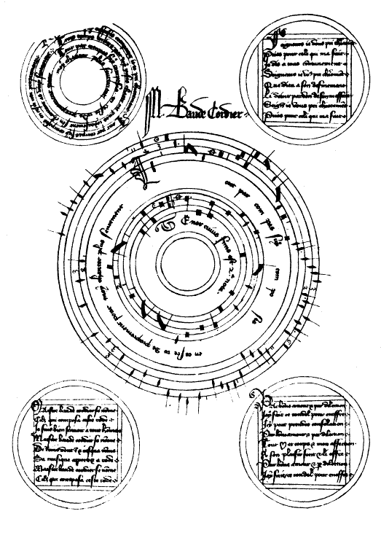
Image: public domain

Léonie Seliger

